EXPERIMENT-3
NAME: Tarun Antony M
ROLL NO: 240701556

1.COMMAND LINE INTERFACE:
PYTHON CODE:
import os
import sys
def rename_file(old_name, new_name):
try:
os.rename(old_name, new_name)
print(f"File renamed from {old_name} to {new_name}")
except FileNotFoundError:
print(f"Error: {old_name} not found.")
except Exception as e:
print(f"An error occurred: {e}")

def survey():
print("Rate your satisfaction with the following interfaces (1-5):")
cli_satisfaction = int(input("CLI (1-5): "))
gui_satisfaction = int(input("GUI (1-5): "))
vui_satisfaction = int(input("VUI (1-5): "))
print(f"\nYour satisfaction ratings:")
print(f"CLI: {cli_satisfaction}")
print(f"GUI: {gui_satisfaction}")
print(f"VUI: {vui_satisfaction}")

if __name__ == "__main__":
if len(sys.argv) != 3:
print("Usage: python rename_file_cli.py <old_filename> <new_filename>")
else:
rename_file(sys.argv[1], sys.argv[2])
survey()

CODE PIC:
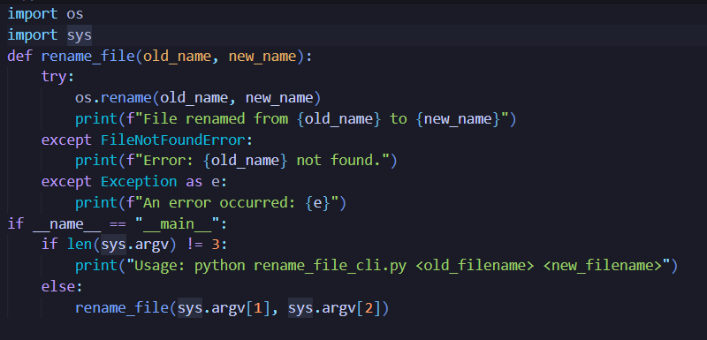
OUTPUT:

2.GRAPHICAL USER INTERFACE:
PYTHON CODE:
import tkinter as tk
from tkinter import messagebox
import os

def rename_file():
old_name = old_filename_entry.get()
new_name = new_filename_entry.get()

try:
os.rename(old_name, new_name)
messagebox.showinfo("Success", f"File renamed from {old_name} to {new_name}")
except FileNotFoundError:
messagebox.showerror("Error", f"File {old_name} not found.")
except Exception as e:
messagebox.showerror("Error", f"An error occurred: {e}")

root = tk.Tk()
root.title("File Renamer")

tk.Label(root, text="Old Filename:").grid(row=0, column=0)
tk.Label(root, text="New Filename:").grid(row=1, column=0)

old_filename_entry = tk.Entry(root)
old_filename_entry.grid(row=0, column=1)

new_filename_entry = tk.Entry(root)
new_filename_entry.grid(row=1, column=1)

rename_button = tk.Button(root, text="Rename File", command=rename_file)
rename_button.grid(row=2, columnspan=2)

root.mainloop()

def survey():
print("Rate your satisfaction with the following interfaces (1-5):")
cli_satisfaction = int(input("CLI (1-5): "))
gui_satisfaction = int(input("GUI (1-5): "))
vui_satisfaction = int(input("VUI (1-5): "))
print(f"\nYour satisfaction ratings:")
print(f"CLI: {cli_satisfaction}")
print(f"GUI: {gui_satisfaction}")
print(f"VUI: {vui_satisfaction}")
survey()

CODE PIC:
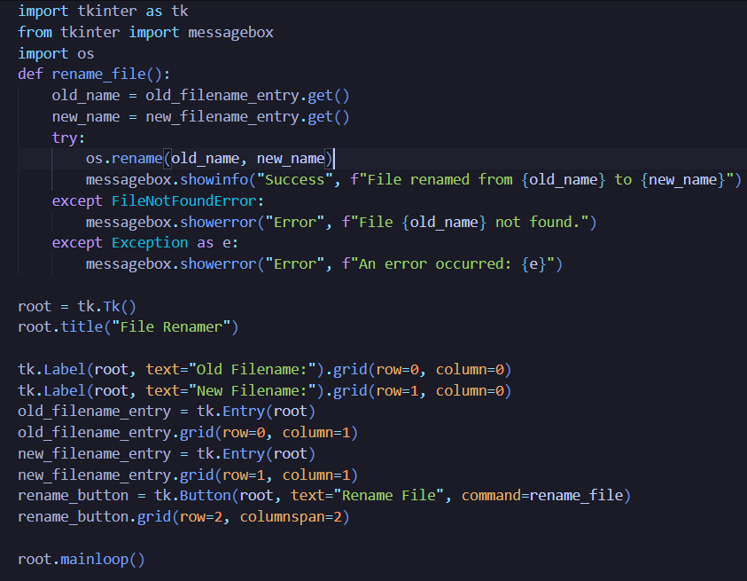
OUTPUT:
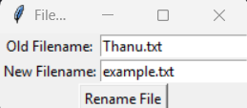

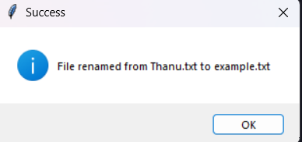

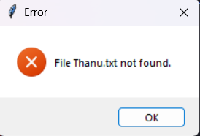
3.VOICE USER INTERFACE:
PYTHON CODE:
import speech_recognition as sr
import os

def listen_once(prompt):
recognizer = sr.Recognizer()
mic = sr.Microphone()

print(prompt)
with mic as source:
recognizer.adjust_for_ambient_noise(source, duration=1)
audio = recognizer.listen(source)

try:
text = recognizer.recognize_google(audio)
text = text.lower().strip()
text = text.replace("dot", ".").replace(" ", "")
print("Heard:", text)
return text

except sr.UnknownValueError:
print("Could not understand audio.")
return None
except sr.RequestError as e:
print(f"Speech service error: {e}")
return None

def rename_file_from_voice():
old_name = listen_once("Say the OLD file name:")
if not old_name:
print("Old filename not captured.")
return

new_name = listen_once("Say the NEW file name:")
if not new_name:
print("New filename not captured.")
return

try:
os.rename(old_name, new_name)
print(f"File renamed from '{old_name}' to '{new_name}'")

except FileNotFoundError:
print(f"File '{old_name}' not found.")
except FileExistsError:
print(f"File '{new_name}' already exists.")
except Exception as e:
print(f"Error: {e}")

def survey():
print("Rate your satisfaction with the following interfaces (1-5):")
cli_satisfaction = int(input("CLI (1-5): "))
gui_satisfaction = int(input("GUI (1-5): "))
vui_satisfaction = int(input("VUI (1-5): "))
print(f"\nYour satisfaction ratings:")
print(f"CLI: {cli_satisfaction}")
print(f"GUI: {gui_satisfaction}")
print(f"VUI: {vui_satisfaction}")

if __name__ == "__main__":
print("Voice Controlled File Renamer")
rename_file_from_voice()
survey()

CODE PIC:
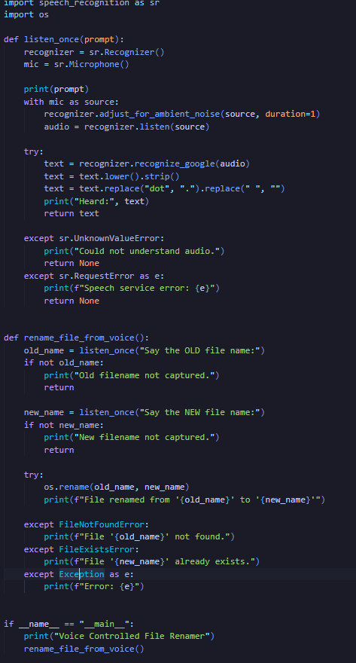

OUTPUT:

